A. SIGNIFICANCE
A1. Reducing the global burden of TB is a moral and economic imperative. In 2023, there were an estimated 10.8 million new cases and 1.25 million deaths from TB. From 2020 to 2050, the projected economic losses associated with mortality from TB were estimated at $17.5 trillion USD, with the greatest economic losses forecasted in the Asian and Pacific regions and the greatest life expectancy losses in sub-Saharan Africa. [1] In the U.S., TB cases have surged, with >10,000 TB cases reported in 2024, marking an 8% increase from 2023 and the highest number since 2011. [2] Treatment of drug-resistant TB can cost > $100,000 USD, underscoring the financial costs and health systems burden of this upward trend. [3]

A2. Global and U.S. TB control are backsliding, and better tools are needed to renew progress toward TB elimination. Despite the existence of scalable diagnostics and effective treatment regimens for TB (the disease), progress towards curbing the epidemic has been slow and was further set back by the COVID-19 pandemic. [4] In the U.S. and elsewhere, the goal of TB elimination (incidence of <1 case per million population) is not achievable without the introduction of new tools that can address longstanding shortfalls in our ability to diagnose, treat, and ultimately interrupt transmission. The causal agent of TB, Mycobacterium tuberculosis (Mtb), is an airborne pathogen. It is estimated that only 5-10% of those with Mtb infection will ever develop TB over the course of their lifetime [5], with risk of progression highest two months to two years after infection and declining markedly thereafter. [6], [7] To date, we have a limited understanding of who will progress to TB among those who are infected. The field-standard test for Mtb infection is the interferon gamma-release assay (IGRA), which detects immunological sensitization to Mtb – indicating a past exposure – but does not provide any information about timing of infection or likelihood of progressing to TB. As a result, IGRA results on individuals are poorly predictive of progression to TB and IGRA population prevalence fails to provide any meaningful information on real-time infection rates.

A3. Novel diagnostics that can identify recent Mtb infection could be a paradigm-shifting advance for TB prevention and care. A new blood-based biomarker test (‘TB-TASA’) has demonstrated higher levels of Mtb-specific T-cell activation in peripheral blood of people with recent Mtb infection than in individuals who were infected less recently (with ‘persistent’ infection). [8], [9] This finding is consistent with data from a previous study which demonstrated increased inflammation and activation of bulk CD4 T cells immediately before clinical onset of TB. [10] The potential of biomarker-based assays to reliably distinguish between recent and persistent Mtb infection, if scalable, could transform our understanding of TB epidemiology. Importantly, given that risk of progression to active TB is highest in the 1-2 years after Mtb infection, a reliable test for recent Mtb infection would be informative both for assessing individual risk of progression and for understanding recent epidemiological trends (i.e., the force of Mtb infection).

A4. New vaccines promise to deliver a ‘step change’ for global TB prevention efforts, but their development has been painstakingly slow. According to estimates from the World Health Organization (WHO), a moderately effective TB vaccine for adults and adolescents could cumulatively avert 37.2–76.0 million cases and 4.6–8.5 million deaths before 2050. [11] However, the pace of TB vaccine development has been severely limited by the size and scale of late-stage trials required to evaluate their efficacy. Even in countries where TB burden is relatively high, most people who are infected with Mtb will not develop disease. Among those who do develop TB, clinical illness may not present until months or years after infection. As a result, most trials enroll healthy individuals already with Mtb infection (i.e., IGRA+) with clinical TB as the primary endpoint. However, IGRA is not optimal as a surrogate marker of future risk of developing TB, because evidence suggests that a ‘resistant’ immune phenotype is present in approximately 20% of the population; these individuals will not convert an IGRA result despite intense exposure to Mtb. [15], [16] Using IGRA status to screen for eligibility could lead to overestimation of progression risk to TB among participants, especially in older adult populations in which IGRA is more poorly predictive of progression. [20]
Even when including IGRA+ trial participants, sample sizes for current vaccine trials are exceedingly large: the ongoing Phase 3 trial of a leading vaccine candidate, M72-AS01_{e}, will enroll >20,000 participants with Mtb infection and will follow them for three years. Trials must also be conducted in geographic locations where transmission is high enough, and enough incident cases will occur, to reliably estimate vaccine efficacy. Identifying appropriate sites currently requires large observational studies measuring the prevalence of Mtb infection using IGRA and estimating the expected incidence of TB cases. Because 10-15% of positive IGRA responses revert to negative each year, [17] estimates of transmission intensity using IGRA prevalence underestimate the true annual risk of infection by a factor of 5–10 depending on the setting. [18],[19] Incorrectly estimating the annual risk of Mtb infection using IGRA makes it difficult to rank possible sites by transmission intensity and could ultimately lead to unsuccessful trials.

Taken together, these challenges have slowed the progress of TB vaccine development: for M72-AS01_{e}, five years elapsed between the release of the phase 2b trial results and the first patient enrolled in the phase 3 trial. We propose that new diagnostic tools that can (i) better measure transmission intensity in candidate vaccine trial sites and (ii) identify participants most likely to progress to TB, could markedly reduce both the size and duration of these trials, accelerating the evaluation and, ultimately, successful delivery of an effective vaccine for TB.

A5. Current public health programs for TB prevention have limited ability to monitor their performance in real-time. The surveillance activities of national TB programs in countries with high burdens of TB are largely limited to tracking reported cases of clinical TB (“case notification rates”). However, the case notification rate is a highly lagged indicator of incident infection, which can occur months or even years before disease, and subject to systematic bias due to programmatic gaps in case detection, diagnosis, and reporting. Ideally, TB programs would instead have a sensitive, real-time indicator of incident Mtb infection. A test for recent Mtb infection, either alone or in combination with IGRA testing, could be used to routinely track the intensity of transmission through simple, cross-sectional prevalence studies, facilitating the rapid evaluation of epidemiological trends and TB program performance. This tool could also be used to evaluate the population effectiveness of specific interventions aiming to prevent transmission, such as active case finding efforts, educational campaigns, and new vaccines. We propose that tests of recent infection would offer a significant improvement over standard surveillance methods, providing an essential new tool which can inform program planning and allocation of limited resources.

A6. Different applications for tests of recent Mtb infection may require different test characteristics. In 2017, the WHO defined a Target Product Profile describing the minimum requirements for TB diagnostic tests used for predicting TB progression. [12] According to this profile, tests to identify TB progressors should have a sensitivity and specificity of ≥90% (minimum 75%) and their performance should be evaluated over a 2-year time frame. However, target profiles present one set of ideal test characteristics, which may not be suitable for all applications or epidemiologic contexts in which the test may be used.
Different use cases may require different levels of sensitivity and specificity. Using a test to screen for eligibility in a vaccine trial requires high specificity to avoid misclassification of distant Mtb infections as recent, which would yield fewer incident TB cases and could result in an unsuccessful trial. If being used to select a trial site, false positives could lead to artificially high estimates of transmission intensity, which could result in siting a trial in a location where rates of infection are not sufficiently high. Time to positivity (TTP, how quickly after infection a person tests positive) and duration of positivity (DOP, time from initial positivity to reversion) (Figure 1) will also influence the utility of a test across different applications. Evaluating trends in transmission intensity requires a sufficiently short TTP to minimize delays in detection. The DOP must be sufficiently long to ensure that it can detect enough infections to produce reliable estimates of infection incidence, but short enough to offer a reasonably precise indication of infection time.
Understanding the optimal and acceptable ranges of characteristics of a test (e.g., sensitivity, sensitivity, TTP) and the potential tradeoffs (e.g., a short vs. long DOP) for specific applications will identify those for which TB-TASA may be acceptable, based on its known performance characteristics.
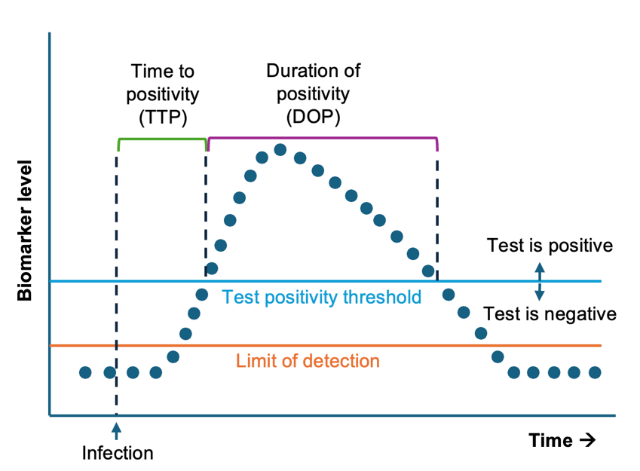
Figure 1. Sensitivity, specificity, time to positivity (TTP, time from infection to initial positivity) and duration of positivity (DOP, time from initial positivity to reversion) will influence the utility of a test for a specific use-case.

A7. Defining the epidemiologic contexts in which TB-TASA, and other similar assays, will be useful can facilitate their rapid use. Even if a test meets the minimum performance characteristics for a specific use-case, designing an optimal implementation plan will depend on the epidemiologic context in which it is used. The population age distribution, force of infection (and therefore rates of Mtb reinfection), and other factors such as HIV prevalence may influence the utility of a test for recent Mtb infection in different contexts. Moreover, the importance of understanding DOP or TTP for use in a particular epidemiologic setting could provide the rationale for observational studies to more directly test these test characteristics if they are not already well understood. In summary, understanding how TB-TASA and other similar tests may perform under different conditions can focus research and implementation efforts on specific use-cases where these tests will be most effective, and guide continued efforts to further characterize and implement these tests for those applications.
Preliminary data. Data on the performance of TB-TASA from observational studies conducted by our team and from preliminary models developed by our team support the premise of this proposal and demonstrate our ability of to successfully deliver on its objectives.

TB-TASA is an innovative diagnostic that can differentiate recent versus remote Mtb infection. TB-TASA is an immune-cell based diagnostic that measures the relative activation of Mtb-specific T-cells, a biomarker that is directly responsive to within-host Mtb antigen load and bacillary burden. Mtb bacillary burden and antigen load are expected to be higher during early Mtb infection, higher during progression to disease, and lower or absent in individuals who achieve cure via anti-TB therapy or clearance of infection. TB-TASA identifies Mtb-specific T cells by detecting intracellular IFNγ and TNF expression following stimulation with Mtb-specific antigens (e.g. ESAT-6 and CFP-10) and determines the level of activation with the Mtb-specific T cell population. [9], [13], [14] The readout of TB-TASA is the proportion of HLA-DR+ Mtb-specific T cells measured by flow cytometry. Figure 3 shows discrimination between persistent and recent Mtb infection among adolescents (Figure 3a) and children in a household contact study (Figure 3b), measured using the QuantiFERON (QFT) assay, a type of IGRA.⁹ Both adolescents and children who recently converted from QFT- to QFT+ (within 6 months, reflecting recent Mtb infection) had significantly higher TB-TASA readouts than those with pre-existing, persistent QFT+ (attributable to Mtb infection in the more distant past). In the adolescent cohort, the overall sensitivity and specificity for differentiating recent versus distant Mtb infection in persons with detectable ESAT-6 and CFP-10 T cell responses were 61% and 83%, respectively, with an area under the receiver-operator characteristic curve of 0.74. In the household contact study, the overall sensitivity and specificity for differentiating recent versus distant Mtb infection in children with detectable ESAT-6 and CFP-10 T cell responses were 91% and 67%, respectively, with an area under the receiver-operator characteristic curve of 0.85. Although this preliminary data is promising, the performance of TB-TASA to in older individuals, who are less likely to have a primary Mtb infection, in settings with high force of infection, where many infections are expected to be repeat infections, and among persons living with HIV, who mount weaker responses to the antigens in IGRAs, remain important potential sources of variability in test performance which we plan to directly address in this proposal.
Figure 3: Evaluation of TB-TASA for differentiating recent versus remote Mtb infection. TB-TASA scores are significantly higher in adolescents (a) or children who were household contacts (b) with recent QFT conversion (QFT- to QFT+ within 6 months) than in those with persistently positive QFT, with AUC of 0.74 and 0.85 in adolescents and children, respectively. Published data from adolescents were reanalyzed, and unpublished data from children were analyzed using an automated computational pipeline built using the R package OpenCyto. Data from participants with an ESAT-6/CFP-10 response are shown. Responders are defined by a fishers’ exact test (p < 0.01), and a greater than 3-fold change compared to the negative control (PBS). The dashed line at 10% indicates the threshold for TB-TASA positivity [REF: https://doi.org/10.12688/verixiv.1031.1].

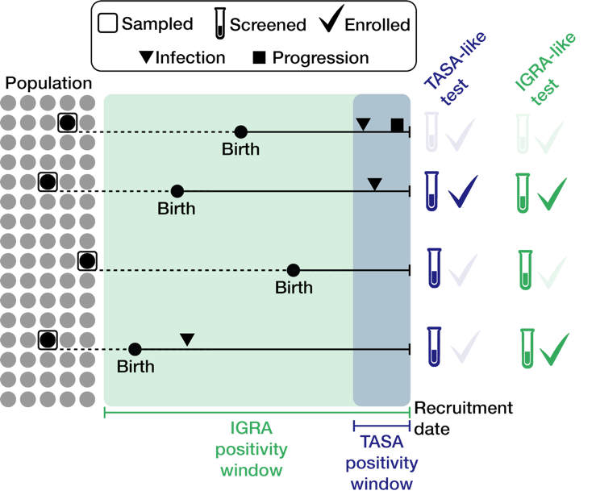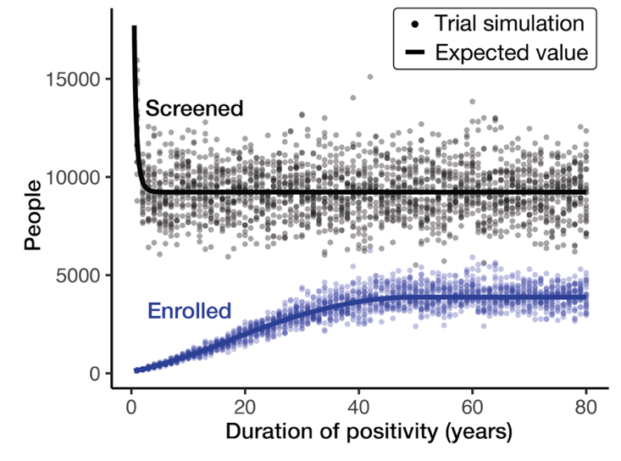Figure 2. Model schematic and preliminary trial simulation results. (Left panel) Illustration of the vaccine trial simulation model. Individuals are sampled randomly from a synthetic population (grey circles). Infection trajectories, consisting of the timing of infection and active TB progression (triangles, squares) are simulated for each person. Sampled individuals without active TB are screened using a diagnostic test with a given DOP (positivity window). Those who test positive (i.e., whose infection occurred within the test’s positivity window) are enrolled. Model outputs are the number of people sampled, screened, and enrolled for a test with a given DOP. (Right) Screening (black) and recruitment (blue) numbers for 2,000 simulated vaccine trials. For each simulated trial, enrollment continues until reaching N = 50 progressors. Trials were simulated for screening tests with DOP ranging from months (TASA-like) to years (IGRA-like).

We have developed a preliminary model, described in the left panel of Figure 2, that can simulate TB vaccine trials given a community’s age distribution and the incidence of Mtb infection. For each person in the community, we simulate an “infection trajectory”, consisting of the timing of Mtb infection and of progression to active TB. Then, we sample individuals at random. If they have not developed active TB, they are screened using a test with a DOP of k years (months for TB-TASA, years for IGRA). Individuals who test positive are enrolled and we simulate TB progression for the enrolled cohort over a 3-year trial period. We continue sampling from the community until we enroll N individuals who progress during the trial, where N is a function of the trial’s power. For each simulation, we measure the number of people sampled, screened, and enrolled to reach N progressors.
In preliminary simulations, shown in the right panel of Figure 2, the vaccine trial size needed to enroll N=50 progressors steadily declines as a test’s DOP shrinks (i.e., from IGRA-like to TB-TASA-like tests). This is because screening tests with a short DOP help exclude individuals with long-standing persistent Mtb infection. In one scenario, relative to an IGRA-like test, a TB-TASA-like test with a 6-month DOP could yield an expected 32-fold reduction in trial size (121 vs. 3,879 enrolled) with only a 1.9-fold increase in the number screened (17,720 vs. 9,234 screened). A test with a modestly longer DOP, e.g., one year, could generate a similar 26-fold expected reduction in trial size (147 enrolled) with just a 1.3-fold increase in the number screened (11,982 screened). These findings are based on various assumptions, including a uniform age distribution, constant TB incidence, and perfect test sensitivity/specificity within the test’s positivity window. Nevertheless, this modeling framework provides a strong basis for simulating trials under more realistic conditions.

B. INNOVATION
This will be the first study to assess how a test for recent infection might revolutionize TB vaccine trial design and intervention efficacy monitoring. Our study is innovative in four ways:
- We will assess the potential of cutting-edge assays to advance high-priority goals for global TB control. The field of TB has become accustomed to suboptimal tools (i.e., IGRA) to assess infection status and lagged, problematic metrics (i.e., case notification rates) to monitor TB program performance, a reality that is unacceptable in the face of this massive public health challenge. Using rigorous model-based approaches to identify practical applications for promising new tools is a novel scientific approach that can accelerate and expand the impact of these new tools.
- We will leverage innovative methods that can clearly delineate recent and persistent infection using immunological signatures of Mtb antigen-specific T cell activation (TB-TASA). TB-TASA is a novel immune-cell based diagnostic that measures the activation of Mtb-specific T-cells, a biomarker directly responsive to host Mtb antigen load and bacillary burden. This is one of the first assays to distinguish between recent and persistent infection and could revolutionize our understanding of TB epidemiology and transmission.
- We will expand the use-cases for this assay beyond clinical management of Mtb-exposed persons, to understand the enormous breadth of applications of a test for recent Mtb infection. Previous development and validation of this assay have focused on determining eligibility for TB preventive therapy. We propose to explore the potential of this new assay to significantly advance the fields of vaccine clinical trial design and TB program surveillance and evaluation.
- We propose an innovative, results-focused partnership between test developers (SATVI), vaccine clinical trialists (IAVI), epidemiologists, and mathematical modelers. We will build a broad team that contains expertise required to rapidly develop and roll out a new assay for use in key public health applications. We will work closely with each partner to ensure that modeling work is reflective of and responsive to scientific and practical considerations for each use-case. We will ensure that the outputs of this work (i.e., recommendations for vaccine trial designs and further observational studies to characterize test performance) are practical and actionable.
C. APPROACH
Our team. We have convened a multidisciplinary team of epidemiologists (Dr. Nelson), clinicians (Dr. Brown), mathematical modelers (Dr. Kissler), diagnostics specialists and TB-TASA developers (Dr. Musvosvi, SATVI, see LoS), and vaccine triallists (Dr. Pelzer, IAVI, see LoS) to carry out this work. The investigator team (Drs. Nelson, Brown, and Kissler) will consult directly with TB-TASA developers and vaccine triallists routinely through the project (bimonthly meetings with Dr. Musvosvi, quarterly meetings with Dr. Pelzer). Their input will shape the development of models and modeling scenarios as well as the interpretation and presentation of results. Collectively, this team is dedicated to the translation of leading-edge tests for recent Mtb infection into key practical applications for TB vaccine development and epidemiological surveillance. Our work will proceed through the following two aims:
Aim 1. Define the requisite performance characteristics of a test for recent Mtb infection to inform planning and execution of more efficient TB vaccine trials.
Rationale: To observe enough cases of TB to reliably estimate efficacy, vaccine trials must be sited in locations where the incidence of TB is sufficiently high and include individuals who are at high risk of progression to TB. Most efficacy trials currently address this challenge by carrying out resource-intensive IGRA prevalence studies at potential trial sites and, once trial sites are selected, recruiting already-infected (IGRA+) individuals into trials. Tests for recent Mtb infection could be used to more precisely estimate annual risk of infection leading to more informed trial siting decisions and allow for selection of trial participants who have been recently infected and therefore have the highest risk of progressing to TB, ensuring the rate of endpoint accrual required for a successful trial. To compare a novel test for recent infection against the field-standard IGRA for both applications, we will undertake two simulation studies.
We will simulate use of a recent infection test in vaccine efficacy trials under different assumptions about test characteristics to:
  - Calculate the annual risk of Mtb infection to optimize trial site selection.
  - Screen potential trial participants to enrich trial populations for individuals likely to develop TB.
We will quantify the added value of a test for recent Mtb infection on vaccine trial power and sample size requirements and identify the optimal and acceptable test characteristics for each use. We will evaluate the suitability of TB-TASA for use in vaccine trials and define the epidemiologic conditions under which it could be deployed for this purpose.
Models (Aim 1.1): We will simulate a comparison between IGRA prevalence surveys and surveys using a novel test for recent infection to estimate the annual risk of Mtb infection (ARI). We will explore the differences in the requisite sample size of prevalence surveys under different assumptions about the true ARI, with values that reflect the likely range across high TB burden countries. We will use well-established values for the test characteristics of IGRA but vary the characteristics of the test for recent infection, including duration of positivity, sensitivity and specificity to identify recent Mtb infection (Figure 1). As a basis for these simulations, we will create synthetic populations with simulated individual-level TB infection histories, which we will derive using the population’s age structure and historical TB incidence. [x] We will then simulate clinical trials under the estimated ARIs to determine the differences in trial sample size required based on whether ARI is calculated using IGRA or a novel test for recent infection. We will propose optimal (greatly outperforms IGRA in all conditions) and acceptable (moderately outperforms IGRA under most conditions) test performance characteristics of a novel test of recent Mtb infection for accurately determining ARI.
Models (Aim 1.2): We will simulate TB vaccine trial recruitment. We will assess how different assumptions about ARI, trial catchment area, trial power, and test characteristics (e.g., sensitivity, specificity, and DOP) impact the total number of people screened and enrolled in a trial. We will determine how recruitment effort, measured in terms of the number of people screened and the time needed to reach enrollment targets, varies as a function of the screening test’s DOP, with DOP ranging from months (TB-TASA-like) to years (IGRA-like). We will extend previous methods to determine enrollment targets that achieve 80% power for detecting a range of vaccine efficacies, given the gating test’s characteristics. [x] Based on this analysis, we will identify optimal and acceptable screening test characteristics, as in Aim 1.1.
Outputs of this analysis: Based on our modeling results, we will work closely with TB-TASA developers at SATVI (see LoS from Dr. Musvosvi) to evaluate whether TB-TASA is potentially suitable for (1) site selection and/or (2) trial participant screening. We will compare the sample size requirements when using TB-TASA for trial site selection and participant screening to the sample size required using IGRA. We will identify the epidemiologic conditions (true ARI, reinfection rates, HIV/TB co-prevalence) under which TB-TASA outperforms IGRA and is a preferred alternative. We will also explore different thresholds for TB-TASA positivity to determine the marginal benefits of incremental improvements in sensitivity and specificity. If it appears that TB-TASA will be useful for either purpose, we will work closely with IAVI (see LoS from Dr. Pelzer) to propose and describe specific observational studies and trial designs that leverage TB-TASA.

Aim 2. Define the requisite performance characteristics for a test for recent Mtb infection to inform real-time monitoring of Mtb transmission intensity in high-burden settings.
Rationale: Current approaches to monitoring TB program performance in high-burden settings are largely limited to tracking TB case rates, which rely on clinical diagnosis and/or microbiological confirmation of TB. There are two main challenges with this approach to program performance. First, unlike many acute infections for which transmission events occur just days before illness, Mtb transmission can occur months or years before a resultant clinical case of TB is diagnosed and reported to the health system. Combined with months-long delays in seeking care after symptoms begin, [21], [22] the result is that TB case data lags infection incidence significantly. Second, estimates suggest that up to 50% of all TB cases globally are undiagnosed. [23] This is due to many factors, including the poor performance of diagnostic tests, concentration of TB among people with limited access to healthcare, and the stigma that discourages many from seeking care. [24] Undiagnosed, asymptomatic TB contributes significantly to Mtb transmission. [25] As a result, measures that rely only on symptomatic, diagnosed cases are a poor indicator of real-time epidemiologic conditions. Tests for recent infection offer a significant improvement in the ability to monitor trends in infection incidence, offering a leading indicator of clinical case incidence.
Models: To compare a novel test for recent Mtb infection against TB case surveillance for measuring epidemiologic conditions, we will fit a dynamic compartmental model of Mtb transmission to epidemiologic data from high-burden country settings. This model structure and parameter values will be based on previously published, well-established models. [26], [27], [28] We will use this model to simulate (i) stable transmission of Mtb, (ii) periods of rising Mtb transmission, (iii) periods of declining Mtb transmission, and (iv) community-wide interventions such as active case finding increased coverage of preventive therapy, and introduction of new vaccines, which are expected to result in reductions in Mtb transmission.
We will compare true infection incidence with TB case notification rates (the current surveillance standard) through time and compare this with infection incidence that could be estimated using a novel test for recent Mtb infection. We will quantify the bias and time to detect changes in transmission under each scenario. We will determine how test characteristics would influence the extent of bias and detection delays. As in Aim 1, we will propose optimal and acceptable product characteristics for a novel test of recent infection for this application.
To estimate the size and scale of population-based surveys using novel tests of recent infection that would be required to estimate Mtb infection incidence, we will simulate such surveys and calculate the required sample size to generate statistically robust estimates of infection incidence to infer current epidemiologic conditions (stable, rising, declining cases and assessment of intervention effectiveness). We will assess the sensitivity of our findings to varying test characteristics (sensitivity, specificity, DOP) and epidemiologic contexts (true ARI, reinfection rates, HIV/TB co-prevalence).
Outcomes of this aim: Based on model results, we will evaluate whether TB-TASA is suitable to track transmission intensity. We will evaluate the sample size of population-based surveys required to estimate Mtb infection incidence and epidemiologic trajectory under known TB-TASA test characteristics. We will also explore different thresholds for TB-TASA positivity to determine the marginal benefits of incremental improvements in sensitivity and specificity. If it appears that TB-TASA will be useful, we will propose and describe specific surveillance procedures or epidemiologic study designs of intervention effectiveness that leverage TB-TASA.
Limitations and alternative strategies.. 1) Although TB-TASA is a promising test of recent Mtb infection, it is possible that evaluation of this assay in different populations could fail to reproduce preliminary results. In particular, there is currently limited data on how TB-TASA performs to distinguish recent from remote Mtb infection in older age groups and among people living with HIV. Our proposal is uniquely suited to address these potential limitations, by modeling uncertainty in test performance in these groups, and incorporating such uncertainty when making conclusions about applications for which TB-TASA may be suitable. If TB-TASA does not reach the minimum acceptable performance standards based on our models, our modeling results will remain broadly applicable to other assays under development. In particular, these include host transcriptomic signatures that are linked to increased risk of progression to TB [29], [30], which could be the focus of future work that builds on the flexible modeling framework we will develop in this project. 2) Gating entry in TB vaccine trials by TB-TASA status may have important implications for vaccine licensure and policy recommendations for broad use. We will work in tandem with Dr. Pelzer to understand and address these issues, including the development phase (phase 2 or 3) at which TB-TASA screening is appropriate, to propose trial designs that are likely to lead to successful vaccine approval. 3) Cost and logistical considerations of implementing tests for recent Mtb infection will not be explicitly evaluated; however, future work should comprehensively assess practical and financial considerations of implementation.
Public health significance. New diagnostics and new vaccines offer immense promise to reduce the global burden of TB. Approaches towards developing new tools should be bold, fast, and rigorous. To that end, we propose to model the potential use-cases of innovative new diagnostics alongside their development, parallelizing key steps in this process to accelerate testing, adoption, and implementation. This project will deliver (1) a target profile for key public health application of tests for recent infection which will guide their further development; and (2) practical insights into the potential impact of these tools for use in vaccine trials and TB programs. Together, these outputs will create a roadmap for the rapid implementation of these tools in curbing the TB epidemic.

Removed text
In this proposal, we will explore the potential impact of such a test for the design and implementation of TB vaccine trials (Aim 1) and for monitoring the performance of public health interventions for TB prevention and care (Aim 2).

effective implementation of these tests could accelerate the pace of vaccine trials and provide a valuable tool to national TB programs that would facilitate monitoring progress towards global goals to end TB.
We will simulate community-wide interventions and assess how quickly and accurately a test for recent Mtb infection, deployed at scale, could evaluate population-level intervention effectiveness. As in Aim 1, we will evaluate the suitability of TB-TASA for this application and define the epidemiologic conditions under which it could be deployed for this purpose.
Importantly, results from Aim 1 have the potential to directly influence future trial planning at IAVI, which is currently developing one of the most promising TB vaccine candidates, MTBVAC. Cite
Specific assets of this team include their uniquely applicable and highly congruent skills and backgrounds, and a strong track record of prior collaborative work. (Dr. Nelson and Dr. Brown have co-authored 5 high-impact peer reviewed publications together.)

REFERENCES
[1] S. Silva, N. Arinaminpathy, R. Atun, E. Goosby, and M. Reid, “Economic impact of tuberculosis mortality in 120 countries and the cost of not achieving the Sustainable Development Goals tuberculosis targets: a full-income analysis,” Lancet Glob. Health, vol. 9, no. 10, pp. e1372–e1379, Oct. 2021, doi: 10.1016/S2214-109X(21)00299-0.
[2] CDC, “Provisional 2024 Tuberculosis Data, United States,” Tuberculosis Data. Accessed: Aug. 14, 2025. [Online]. Available: https://www.cdc.gov/tb-data/2024-provisional/index.html
[3] S. M. Marks and C. A. Winston, “Estimated treatment costs for multidrug-resistant TB in the United States,” Int. J. Tuberc. Lung Dis. Off. J. Int. Union Tuberc. Lung Dis., vol. 28, no. 4, pp. 214–215, Apr. 2024, doi: 10.5588/ijtld.23.0621.
[4] D. Falzon, M. Zignol, M. Bastard, K. Floyd, and T. Kasaeva, “The impact of the COVID-19 pandemic on the global tuberculosis epidemic,” Front. Immunol., vol. 14, p. 1234785, Aug. 2023, doi: 10.3389/fimmu.2023.1234785.
[5] N. A. Menzies et al., “Time Since Infection and Risks of Future Disease for Individuals with Mycobacterium tuberculosis Infection in the United States,” Epidemiol. Camb. Mass, vol. 32, no. 1, pp. 70–78, Jan. 2021, doi: 10.1097/EDE.0000000000001271.
[6] M. A. Behr, P. H. Edelstein, and L. Ramakrishnan, “Revisiting the timetable of tuberculosis,” BMJ, vol. 362, p. k2738, Aug. 2018, doi: 10.1136/bmj.k2738.
[7] H. G. Wiker, T. Mustafa, G. A. Bjune, and M. Harboe, “Evidence for waning of latency in a cohort study of tuberculosis,” BMC Infect. Dis., vol. 10, no. 1, p. 37, Feb. 2010, doi: 10.1186/1471-2334-10-37.
[8] C. A. M. Mpande et al., “Immune profiling of Mycobacterium tuberculosis-specific T cells in recent and remote infection,” EBioMedicine, vol. 64, p. 103233, Feb. 2021, doi: 10.1016/j.ebiom.2021.103233.
[9] C. A. M. Mpande et al., “Antigen-Specific T-Cell Activation Distinguishes between Recent and Remote Tuberculosis Infection,” Am. J. Respir. Crit. Care Med., vol. 203, no. 12, pp. 1556–1565, June 2021, doi: 10.1164/rccm.202007-2686OC.
[10] T. J. Scriba et al., “Sequential inflammatory processes define human progression from M. tuberculosis infection to tuberculosis disease,” PLOS Pathog., vol. 13, no. 11, p. e1006687, Nov. 2017, doi: 10.1371/journal.ppat.1006687.
[11] “An investment case for new tuberculosis vaccines.” Accessed: Feb. 08, 2023. [Online]. Available: https://www.who.int/publications-detail-redirect/9789240064690
[12] “Consensus Meeting Report: Development of a Target Product Profile (TPP) and a framework for evaluation for a test for predicting progression from tuberculosis infection to active disease.” Accessed: Aug. 15, 2025. [Online]. Available: https://www.who.int/publications/i/item/WHO-HTM-TB-2017.18
[13] M. Musvosvi et al., “T-cell biomarkers for diagnosis of tuberculosis: candidate evaluation by a simple whole blood assay for clinical translation,” Eur. Respir. J., vol. 51, no. 3, p. 1800153, Mar. 2018, doi: 10.1183/13993003.00153-2018.
[14] M. Musvosvi et al., “T cell receptor repertoires associated with control and disease progression following Mycobacterium tuberculosis infection,” Nat. Med., vol. 29, no. 1, pp. 258–269, Jan. 2023, doi: 10.1038/s41591-022-02110-9.
[15] L. L. Lu et al., “IFN-γ-independent immune markers of Mycobacterium tuberculosis exposure,” Nat. Med., vol. 25, no. 6, pp. 977–987, June 2019, doi: 10.1038/s41591-019-0441-3.
[16] C. M. Stein et al., “Long-term Stability of Resistance to Latent Mycobacterium tuberculosis Infection in Highly Exposed Tuberculosis Household Contacts in Kampala, Uganda,” Clin. Infect. Dis. Off. Publ. Infect. Dis. Soc. Am., vol. 68, no. 10, pp. 1705–1712, May 2019, doi: 10.1093/cid/ciy751.
[17] J. R. Andrews et al., “The dynamics of QuantiFERON-TB gold in-tube conversion and reversion in a cohort of South African adolescents,” Am. J. Respir. Crit. Care Med., vol. 191, no. 5, pp. 584–591, Mar. 2015, doi: 10.1164/rccm.201409-1704OC.
[18] D. W. Dowdy and M. A. Behr, “Are we underestimating the annual risk of infection with Mycobacterium tuberculosis in high-burden settings?,” Lancet Infect. Dis., vol. 22, no. 9, pp. e271–e278, Sept. 2022, doi: 10.1016/S1473-3099(22)00153-0.
[19] B. Patterson, S. Hermans, R. Wood, and F. Cobelens, “Quantification of tuberculosis exposure in a high-burdened setting,” Sci. Rep., vol. 15, no. 1, p. 22687, July 2025, doi: 10.1038/s41598-024-81558-w.
[20] H. L. Rieder, The Epidemiologic Basis of TB Control. International Union against Tuberculosis and Lung Disease, 1999.
[21] F. Getnet, M. Demissie, N. Assefa, B. Mengistie, and A. Worku, “Delay in diagnosis of pulmonary tuberculosis in low-and middle-income settings: systematic review and meta-analysis,” BMC Pulm. Med., vol. 17, no. 1, p. 202, Dec. 2017, doi: 10.1186/s12890-017-0551-y.
[22] C. T. Sreeramareddy, K. V. Panduru, J. Menten, and J. Van den Ende, “Time delays in diagnosis of pulmonary tuberculosis: a systematic review of literature,” BMC Infect. Dis., vol. 9, no. 1, p. 91, June 2009, doi: 10.1186/1471-2334-9-91.
[23] “Global Tuberculosis Report 2024.” Accessed: Feb. 19, 2025. [Online]. Available: https://www.who.int/teams/global-tuberculosis-programme/tb-reports/global-tuberculosis-report-2024
[24] A. K. J. Teo, S. R. Singh, K. Prem, L. Y. Hsu, and S. Yi, “Duration and determinants of delayed tuberculosis diagnosis and treatment in high-burden countries: a mixed-methods systematic review and meta-analysis,” Respir. Res., vol. 22, no. 1, p. 251, Sept. 2021, doi: 10.1186/s12931-021-01841-6.
[25] J. C. Emery et al., “Estimating the contribution of subclinical tuberculosis disease to transmission – an individual patient data analysis from prevalence surveys,” June 14, 2022, medRxiv. doi: 10.1101/2022.06.09.22276188.
[26] T. Sumner et al., “Modelling the health and economic impacts of M72/AS01E vaccination and BCG-revaccination: Estimates for South Africa,” Vaccine, vol. 42, no. 6, pp. 1311–1318, Feb. 2024, doi: 10.1016/j.vaccine.2024.01.072.
[27] T. S. Ryckman, C. F. McQuaid, T. Cohen, N. A. Menzies, and E. A. Kendall, “Projected health and economic effects of a pan-tuberculosis treatment regimen: a modelling study,” Lancet Glob. Health, vol. 12, no. 10, pp. e1629–e1637, Aug. 2024, doi: 10.1016/S2214-109X(24)00284-5.
[28] N. A. Menzies et al., “Prospects for Tuberculosis Elimination in the United States: Results of a Transmission Dynamic Model,” Am. J. Epidemiol., vol. 187, no. 9, pp. 2011–2020, Sept. 2018, doi: 10.1093/aje/kwy094.
[29] H. C. Warsinske et al., “Assessment of Validity of a Blood-Based 3-Gene Signature Score for Progression and Diagnosis of Tuberculosis, Disease Severity, and Treatment Response,” JAMA Netw. Open, vol. 1, no. 6, p. e183779, Oct. 2018, doi: 10.1001/jamanetworkopen.2018.3779.
[30] S. C. Mendelsohn et al., “Prospective multicentre head-to-head validation of host blood transcriptomic biomarkers for pulmonary tuberculosis by real-time PCR,” Commun. Med., vol. 2, no. 1, p. 26, Mar. 2022, doi: 10.1038/s43856-022-00086-8.

